C:\Users\robert\AppData\Local\Microsoft\Windows\INetCache\Content.Word\GUITAR PARTS 001.tif

15. NAME (T) &

16. NUMBER (A)

THE STRINGS

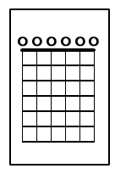

**NAME: ___________________ COURSE: ______**

8. (C)

**COMMUNICATION (C)**

**--------**

**25**

**APPLICATION (4)**

**--------**

**25**

**THINKING (4)**

**--------**

**25**

**KNOWLEDGE (4)**

**--------**

**25**

14. (C)

13. (T)

12. (C)

11. (A)

10. (C)

9. (T)

7. (A)

6. (A)

5. (T)

4. (K)

3. (K)

2. (K)

1. (K)